# GlyTableMaker Application Development Notes

## Spring Boot 3 Implementation details (and changes from Spring Boot 2)

### Configuration

WebSecurityConfigurerAdaptor is no longer being used. The configuration does not need to extend this class. Instead, it is a regular Java class file with the following annotations and methods:



### Account Management

* UserDetailsService: We need to add an implementation for this service and tag it with the annotation @Service



* We also need a DAO that retrieves/saves users from/to Postgres database.



* Another requirement is to implement a userdetails class:

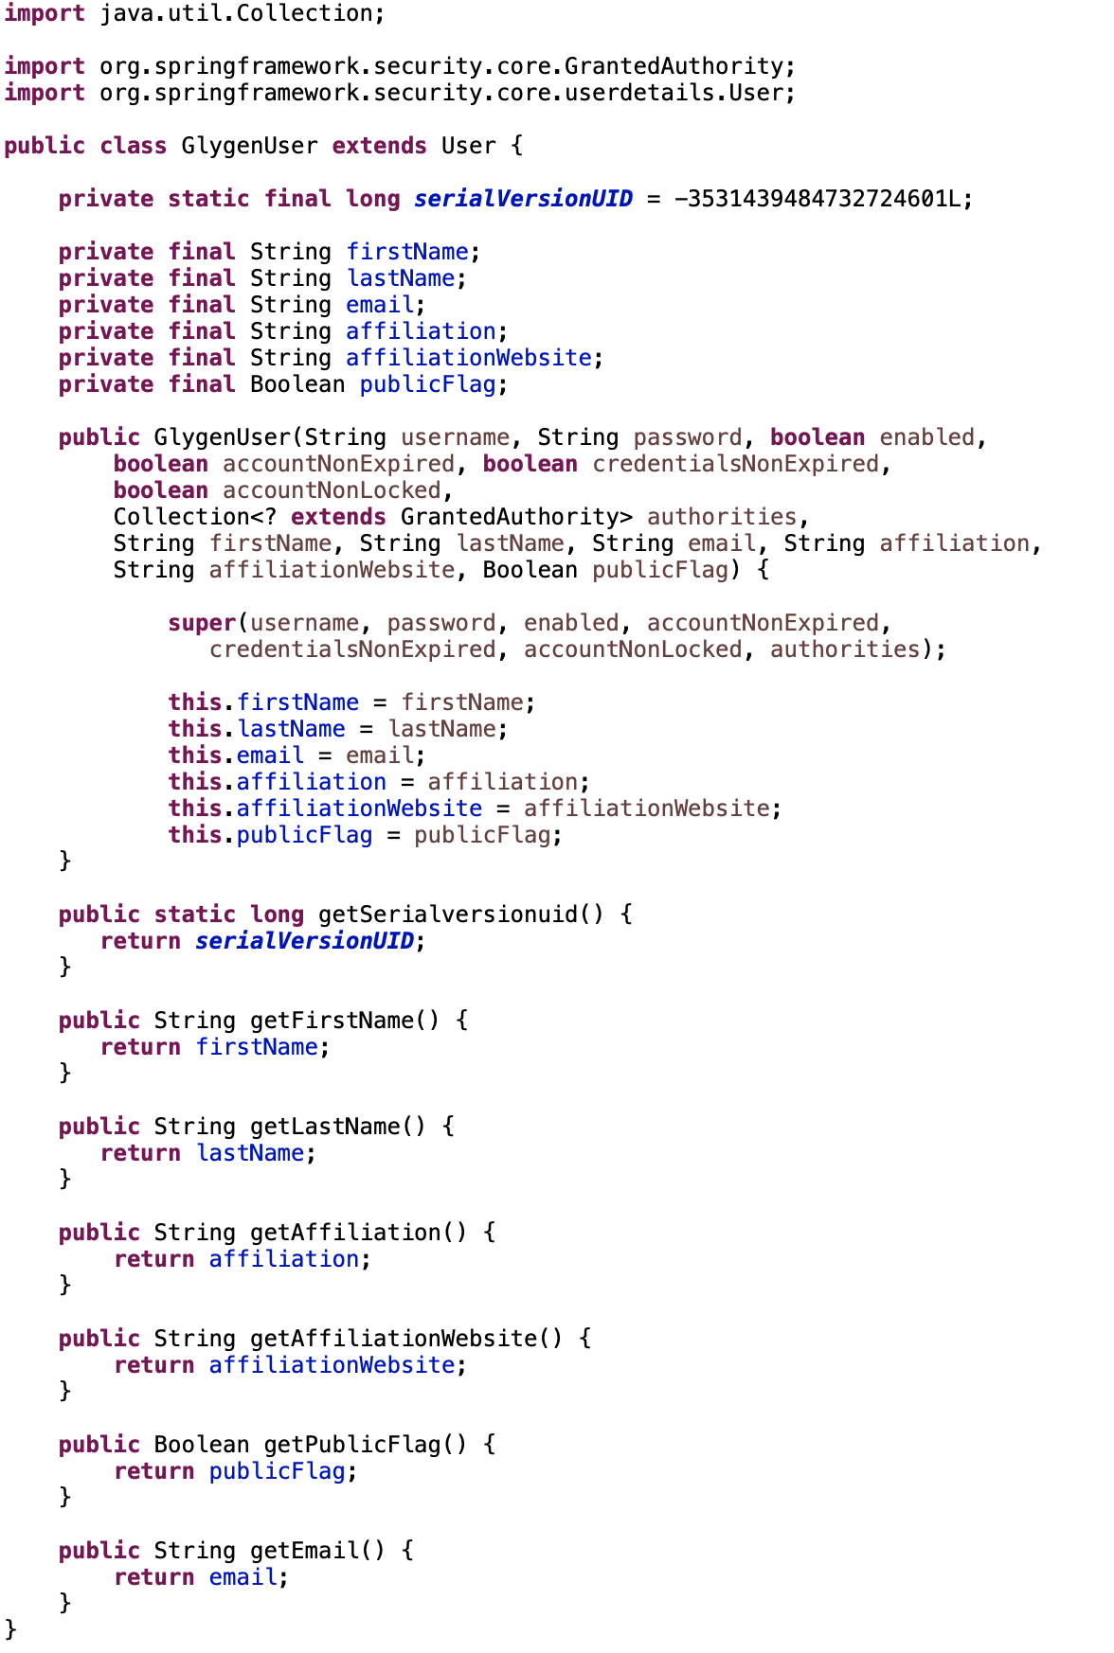

### Encrypting passwords

Refer to the GlygenArrayDevelopmentNotes on how to encrypt passwords to be stored in properties files using PasswordGeneratorUtil.

Then, add the following dependency:

<dependency>

<groupId>com.github.ulisesbocchio</groupId>

<artifactId>jasypt-spring-boot</artifactId>

<version>3.0.5</version>

</dependency>

And add StandardEncyptableEnvironment to the application:



This way, the application.properties and application.yml files can have the encrypted passwords enclosed in ENC:

password: ENC(6fDqWRT97iuR7f1U4akTM918JIiZPKRT)

### Email service implementation

We are using JavaMailSender to send email using Gmail’s smtp server. We need to add the following dependency to use JavaMailSender:

<!-- Email -->

<dependency>

<groupId>org.springframework.boot</groupId>

<artifactId>spring-boot-starter-mail</artifactId>

</dependency>

Another thing to make sure is to generate “App” password for the google account that we will be using to send emails. Google does not allow connections using the username and password. Follow instructions [here](https://knowledge.workspace.google.com/kb/how-to-generate-an-app-passwords-000009237) to generate an App password and use that one instead. The generated password would something like: IOBZ LWTR GRTY WERD

To use this app password, we need to remove the spaces, then generate the encrypted one using “jasypt” and store that in application.yml.